|  |
| --- |
| **NUCL 355 Experiment 11** |
| Forced Convection Heat Transfer  Professor M. Bertandano |
|  |
| School of Nuclear Engineering  Purdue University  Report of the Experiment By:  Weston Cundiff, Stephen Cox, Kara Luitjohan, Patrick Burk, Dominic Ghering, Michael Stryker, Austin Curtis, Matt Metzger, et. Al. |
| **Written By Alex Hagen** |
| **4/15/2011** |
|  |

# Executive Summary

This experiment aimed to give a comprehensive look at heating of moving air within a pipe system. The concepts of this type of system are important to many different types of industry, and the problems considered are not trivial. The important components of the models are the actual qualitative profile, as well as the heat transfer coefficients and Nusselt numbers for the entire system. The Nusselt numbers are also able to be estimated by the Dittus-Boelter correlation because the Reynold’s number can be found.

The apparatus consists of a vertical tube through which air is passed. Flow rates could be controlled through the pipe for different flow rates. A Powerstat power supply powers a coil heater which is wrapped around the pipe wall, and is insulated from the outside using fiberglass insulation. Thermocouples were distributed through the pipe, and an orifice meter was also placed in the pipe, allowing for velocity and temperature measurements to be taken.

The thermocouples and orifice meter made the data acquisition quite simple for this lab. The apparatus was turned on at a certain flow rate and monitored. After the apparatus reached steady state (within .2 deg C in 10 minutes), the data from each of the thermocouples was recorded. This must be done for different flow rates, across different days. In this experiment, it has been done 4 times, with the ambient temperature and also the spatial temperature distribution measured for each flow rate.

Finding the heat transfer aspects of the system were important within data analysis. The Nusselt number for each different flow rate was calculated, and it was compared to the Dittus-Boelter correlation values for these values. The experimental average Nusselt numbers were 21.271±1.86E-06, 18.991±1.39E-6, 15.187±1.14E-6, and 12.679±8.45E-7, respectively. These corresponded to Reynold’s numbers of 223367.62±4893.89, 283245.56±3859.33, 149073.76±7332.86, and 144382.13±7571.14 respectively. Using the constant Prandtl number and the Reynold’s numbers above, the Dittus-Boelter Nusselt Numbers could be calculated, and were found to be 31.246±.548, 37.784±.412, 22.610±.890, and 22.039±.925.

The distribution of the temperature within the piping system was another key point of analysis. The temperatures were taken axially and radially, with the axial temperatures ranging from 36±0.1oC to 43±0.1oC. The radial temperatures ranged from 37±0.1oC to 44±0.1oC. These values should have shown logarithmic increases as the axial direction increased and as the distance from the center of the pipe increased. Instead, these showed more linear correlations, which called into question the accuracy of the thermocouples.

# Introduction and Theory

The entrance effect as well as heating profiles in a heated pipe is very important. The real world applications of this are many, mainly in piping systems. The important components of the models are the actual qualitative profile, as well as the heat transfer coefficients and Nusselt numbers for the entire system. The Nusselt numbers are also able to be estimated by the Dittus-Boelter correlation because the Reynold’s number can be found.

The qualitative distribution of temperatures should be straightforward and will not take much data analysis. Temperatures have been taken, and using the setup of the system, there are two different distributions that can be taken. The entrance effect can be studied by the axial distribution of temperatures, and should look logarithmic. This is because the convection heat transfer is proportional to the reciprocal of the relative temperature. As the relative temperature decreases, the heating rate also decreases, creating a logarithmic profile.

The same is true within a radial distribution of temperatures. The nuance with this setup is that the heat comes from the outside, so the heat should be at a minimum in the center of the pipe. This will create a logarithmic profile with the minimum in the middle, increasing radially. This is the converse of the velocity profile.

Once the qualitative distributions are discussed, the heat transfer coefficient becomes the next parameter of interest. The heat transfer coefficient can be found simply by using an energy balance. The only heat loss occurs through convection to the moving air, and the only heat generation occurs by heating of the pipe. This leaves a simple correlation between the electric energy created and the convection from the pipe to the moving air. This correlation is shown below.

$$h=\frac{VI}{A\left(T_{∞}-T_{s}\right)}$$

As a way to compare this system to other systems, the convection data can be converted to non-dimensional form. This will give us the Nusselt number, a common number used for the analysis of heat transfer systems. The Nusselt number takes into account the pipe diameter as well as the conduction through the pipe wall. This generally gives a good indication of the heat transfer of the system. The correlation is shown below.

$$Nu=\frac{hD_{H}}{k_{w}}$$

Dittus and Boelter created a correlation for systems involving moving fluids to determine the aspects of heat transfer. There are some main assumptions to this correlation. The main assumptions are that there are constant properties through the temperature range, thus a constant Prandtl number. Another assumption is that the flow within the system is turbulent. The correlation for Dittus-Boelter’s model is shown below.

$$Nu=0.023 {\left(Re\right)}^{.8}{\left(Pr\right)}^{.4}$$

This can be used to compare experimental values against the values calculated. The shortcomings of this correlation are that it does not take into account the heat loss within the system, except to convection. Using these tools (the Dittus-Boelter Correlation, the experimental heat transfer coefficient, and the distribution of temperature axially and radially in the system, good conclusions can be drawn about a piping system with heat generation).

# Experiment Description

The equipment setup in this experiment is very straightforward. The apparatus consists of a vertical tube through which air is passed. The air is fed in by a Craftsman vacuum that operates at 6 HP. Using a valve, the flow rate can be adjusted through this pipe through a small range of values. A Powerstat power supply powers a coil heater which is wrapped around the pipe wall, and is insulated from the outside using fiberglass insulation. A pipe tap and an orifice are included inside the vertical pipe, which are attached to a manometer to read the pressure different between the outlet and the inlet.

Besides the setup of the piping and heating elements of the system, the thermocouple setup is also very important. Many thermocouples must be used to take a true distribution of temperature throughout the entire pipe. Thermocouples 1 to 25 (thermocouple 24 is skipped) are placed throughout the axial length of the pipe at a uniform separation. Thermocouple 37 can be adjusted radially along the pipe, to give the radial distribution of the pipe. Thermocouples 31 and 32 read the temperature at the inlet and the outlet. This setup is shown below, and following that is data about the specifics of each piece of equipment used.

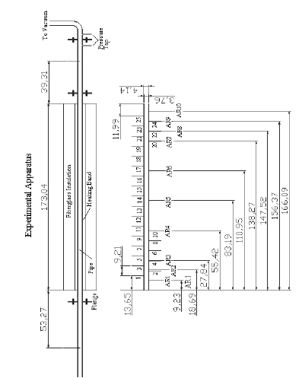

Figure .1 Experimental Setup

|  |  |  |  |
| --- | --- | --- | --- |
| Equipment | Manufacturer | Model #/Serial # | Range |
| Thermomometer | Omega Engineering | Type-E Thermocouple Model 650 | N/A |
| Manometer | Meriam Instruments | 10AA25WM | 50 inH2O |
| Vacuum | Craftsman | N/A | 6 HP |
| PSU | Powerstat | 3PN1368/BP57517 | N/A |

Table .1 Equipment Data

# Data Acquisition

Data acquisition occurred over several days. Because of the time needed for the temperatures to be considered steady state, doing the entire acquisition on one lab day was impossible. The lab sections of Tuesday, Thursday, and Friday combined their data to complete the experiment. This allows for greater amounts of data to be taken, which will lead to better and more accurate data analysis.

The acquisition of the data was quite simple. The apparatus was turned on at a certain flow rate and monitored. After the apparatus reached steady state (within .2 deg C in 10 minutes), the data from each of the thermocouples was recorded. This must be done for different flow rates, across different days. In this experiment, it has been done 4 times, with the ambient temperature and also the spatial temperature distribution measured for each flow rate.

# Analysis and Discussion of Data

The average Nusselt number of this data can be calculated for every different flow rate. This consists of calculating the heat transfer coefficient, using Lumped Capacitance Method, with the only source of heat being the coil heater. This has been thoroughly done in the sample calculations. From there, using the properties of the pipe walls, the Nusselt number could be calculated, and then averaged. This provided four values for average Nusselt number, at different flows. Using the velocity of each of these flows, these could be plotted against Reynold’s Number.

Reynold’s Number and properties of the piping system and fluid, the Dittus-Boelter equation could be solved for these points. A plot is shown below of experimental values of Nusselt number against Reynold’s Number. A red line has been plotted to show the Dittus-Boelter equation and how it matches up to experimental data.

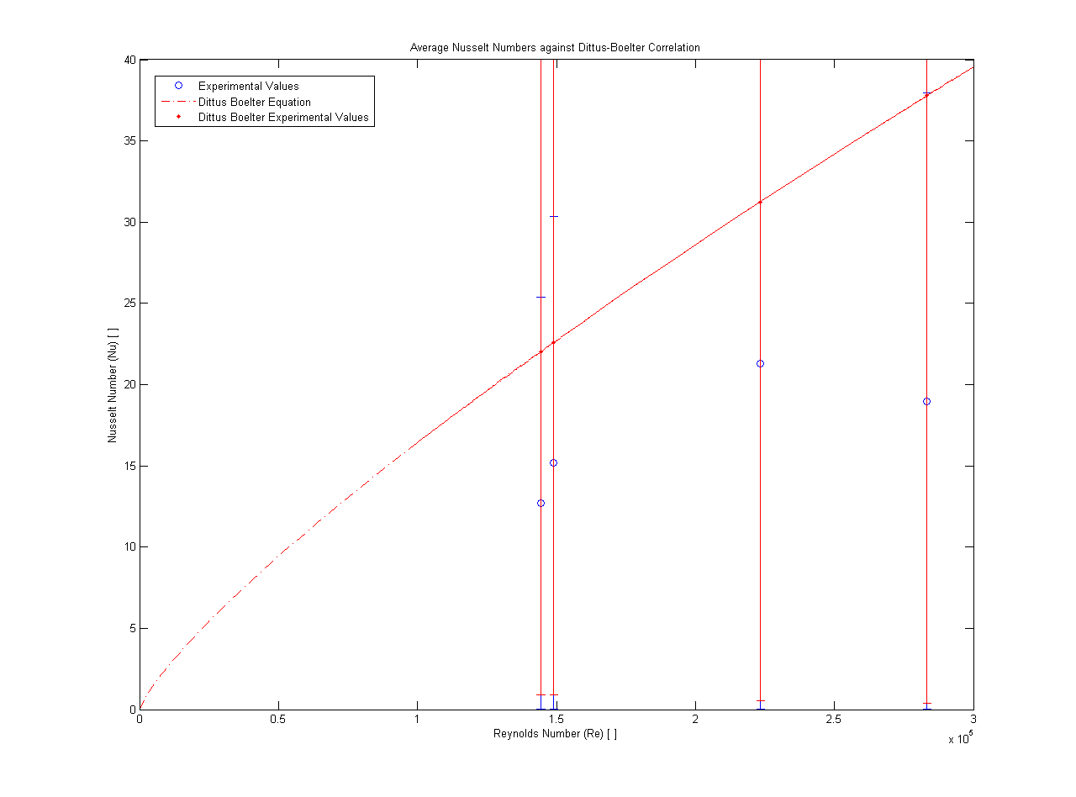

Figure .1 Average Nusselt Numbers against Dittus-Boelter Correlation

As is obvious above, the data is much lower than the Dittus-Boelter equation, showing some heat loss within the experiment (as can be expected). By charting the error bars (which were quite significant on the plot), it can be seen that the experimental points fall within the possible error for the Dittus-Boelter equation (the red error bars). It can also be seen that the Dittus-Boelter equation falls within the possible error for the experimentally calculated values (blue error bars, displayed behind red error bars). This shows that the data is valid, but that some correction should be made to account for heat loss in the system.

As the data is valid and system could be analyzed using the Dittus-Boelter equation and Lumped Capacitance Method, a profile should be made to discuss qualitatively the phenomena occurring within the flow. The thermocouples give both a good axial and radial distribution of temperature. For the axial distribution of temperature, the readings of thermocouples 1 through 24 are evenly spaced down the pipe. They are plotted below. According to entrance effect, they should show a “boundary layer” where the temperature increases logarithmically and then levels off at the fully developed flow temperature. This is because the flow, when it enters a heating section of tubing, takes a while to be heated up to a temperature, but as it is heated, the relative temperature becomes smaller, making the rate smaller. It can never reach above the temperature where it levels off because there is only a certain amount of heat within the system.

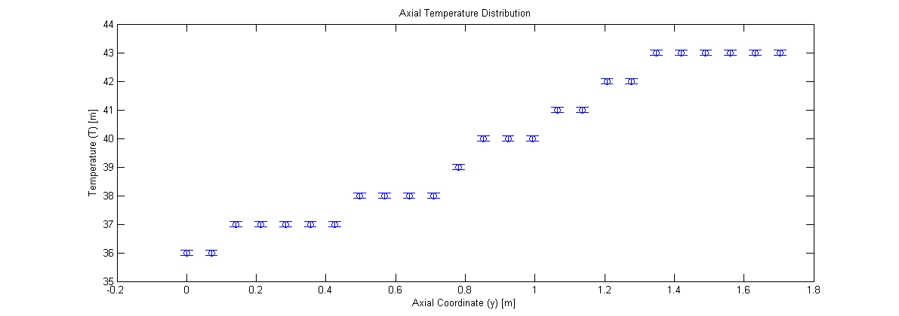

Figure .2 Axial Temperature Distribution

As shown above, the general distribution for the axial temperature is followed, but it does not exactly follow the expected logarithmic shape. This may possibly have occurred because of the accuracy of the thermocouples. The temperatures read from these thermocouples are given with no decimal places, showing that they are only accurate to within the degree. With a higher degree of accuracy, the “plateus” shown above may not exist, and a more logarithmic distribution could be visualized.

Thermocouple 37 was moved within the chamber to show the distribution of temperature within the pipe. A radial coordinate of 0 corresponds to the centerline temperature, whereas the wall occurs at 0.0376 m. Because the heaters are at the walls, the distribution should be greater at the walls than at the middle. The error on this data is again simply the precision error in the instrument. The distribution should be approximately logarithmically increasing at it approaches the wall. This is the same type effect as the entrance effect, as the relative temperature decreases so does the rate of temperature increase. The plot of this radial effect is shown below.

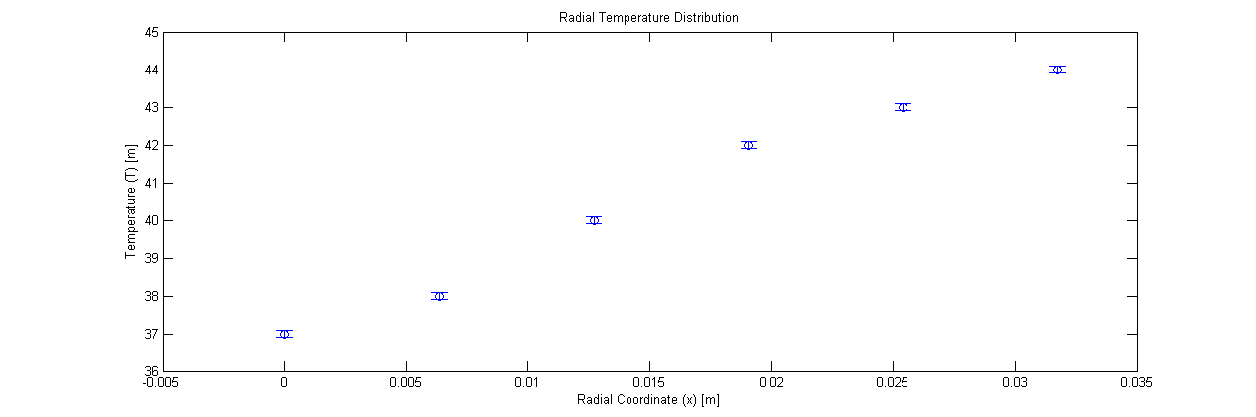

Figure .3 Radial Distribution of Temperatures

As is shown, the correlation is not perfect to the expectations for the radial temperature distribution. The data shows a more linear trend than is expected. This again, is likely because of the resolution of the thermocouples. The data, in this case, has only a range of 7 temperatures, meaning it has to fit into one of 7 bins. It would be very difficult to show a logarithmic distribution through 7 bins.

To tie everything together, a distribution in two dimensions can be made of the conditions within the pipe. This distribution should show that the coolest temperatures are happening at the centerline of the pipe at the entrance, with the largest temperatures happening at the annulus around the outside of the pipe at the top of the flow. The temperature color map below shows this correlation, and matches to expectations. It also seems to show the logarithmic correlations better than the flat plots, especially if the shading were changed to interpolated.

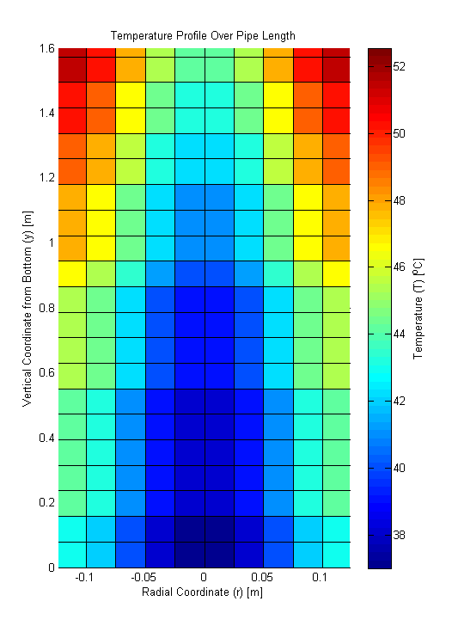

Figure .4 Temperature Profile Over Pipe

# Unusual and Unexpected Findings

There were many unusual findings in this lab. First off, the entrance effect was not as it was expected to be. As explained in the qualitative discussion of this effect, the effect is supposed to be a logarithmic effect. It is, as defined by the experiment, a linear effect for this case. The same is true of the radial temperature distribution. This is possibly because of the resolution of the thermoconductors. A recommendation for better thermocouples will be cited under the proper heading below.

Another unusual finding is how low the Nusselt number points are compared to the Dittus-Boelter correlation. This may possibly be because no heat loss was accounted for in the correlation, but in one section of the experimental data, the Nusselt number decreased at increasing Reynold’s number. This may point to a more fundamental problem in the experimental data than just neglecting of heat loss.

# Conclusions, Recommendations and Comments

This lab has brought about several conclusions, mainly about the Dittus-Boelter correlation, and separately about the entrance effect in heat of pipe systems. The experiment provided us with comprehensive data of the temperature within a pipe, at steady state, through axial and radial directions. It also provided us with information about the velocities within these flows, and the pressure losses and other flow parameters associated with each flow.

The Nusselt number for each different flow rate was calculated, and it was compared to the Dittus-Boelter correlation values for these values. The experimental average Nusselt numbers were 21.271±1.86E-06, 18.991±1.39E-6, 15.187±1.14E-6, and 12.679±8.45E-7, respectively. These corresponded to Reynold’s numbers of 223367.62±4893.89, 283245.56±3859.33, 149073.76±7332.86, and 144382.13±7571.14 respectively. Using the constant Prandtl number and the Reynold’s numbers above, the Dittus-Boelter Nusselt Numbers could be calculated, and were found to be 31.246±.548, 37.784±.412, 22.610±.890, and 22.039±.925.

The differences between these two ways of estimating one number are interesting. The experimental values are significantly lower. This may be because the correlation does not take into effect any heat loss to the surroundings, creating an artificially high values. There is one value for Nusselt number where the higher Reynold’s number correlates to a lower Nusselt number, which makes the correlations look to be different in more than just a simple omission error.

The second set of conclusions concerns the shape of heat transfer within pipe flow. The temperatures were taken axially and radially, with the axial temperatures ranging from 36±0.1oC to 43±0.1oC. The radial temperatures ranged from 37±0.1oC to 44±0.1oC. These values should have shown logarithmic increases as the axial direction increased and as the distance from the center of the pipe increased. Instead, these showed more linear correlations, which calls into question the accuracy of the thermocouples.

**Recommendations:** The recommendations for this lab are that the thermocouples be used to a higher precision. I am certain that the thermocouples could detect the temperature to closer than just one degree Celsius, so they should have been recorded to closer than that. That would have provided better data for our analysis, especially in the spatial distribution of temperature.

# Works Cited

Fox, R. W., McDonald, A. T., & Prichard, P. J. (2004). *Introduction to Fluid Mechanics* (6th ed.). New York: Wiley.

Incropera, DeWitt, Bergman, & Lavine. *Fundamentals of Heat and Mass Transfer* (6 ed.). Wiley.

Munson, Y. O. (2009). *Fundamentals of Fluid Mechanics.* Hoboken, NJ: Wiley and Sons, Inc.

Revankar, S. T. (2011). *Experiment 11: Forced Convection Heat Transfer.* West Lafayette, IN: Purdue University School of Nuclear Engineering.

# Appendices

## Original Data

|  |  |
| --- | --- |
|  | Flow 1 |
| TC 1 | 36 |
| TC 2 | 36 |
| TC 3 | 37 |
| TC 4 | 37 |
| TC 5 | 37 |
| TC 6 | 37 |
| TC 7 | 37 |
| TC 8 | 38 |
| TC 9 | 38 |
| TC 10 | 38 |
| TC 11 | 38 |
| TC 12 | 39 |
| TC 13 | 40 |
| TC 14 | 40 |
| TC 15 | 40 |
| TC 16 | 41 |
| TC 17 | 41 |
| TC 18 | 42 |
| TC 19 | 42 |
| TC 20 | 43 |
| TC 21 | 43 |
| TC 22 | 43 |
| TC 23 | 43 |
| TC 25 | 43 |
| TC 31 (Inlet) | 31 |
| TC 32 (Outlet) | 32 |

Table .1 Original Data for Axial Readings of Temperature

|  |  |
| --- | --- |
| Flow Rate 1 | TC 37 |
| Probe Distance (in) | Radial Temp |
| 0 | 35 |
| 0.25 | 36 |
| 0.5 | 37 |
| 0.75 | 40 |
| 1 | 41 |
| 1.25 | 42 |

Table .2 Original Data for Radial Readings of Temperature

|  |  |  |  |  |  |  |  |  |  |
| --- | --- | --- | --- | --- | --- | --- | --- | --- | --- |
| Pipe OD (m) | Pipe ID (m) | Heated Tube Length (m) | Length to Thermocouple (m) | | Distance b/w odd TCs (m) | Orifice Diameter (m) | Pipe OR (m) | Insulation Thickness (m) | D from insulation to nut (m) |
| 0.04135 | 0.0376 | 1.7304 | | 0.1365 | 0.0921 | 0.0183 | 0.05207 | 0.0635 | 0.066675 |

Table .3 Geometry Data

|  |  |  |
| --- | --- | --- |
| Initial Temp (Cel.) | Voltage | Amperage |
| 29 | 30 | 4 |

Table .4 Heating Data

## Reduced Data

|  |  |  |  |  |  |  |  |
| --- | --- | --- | --- | --- | --- | --- | --- |
|  | FR1 | Heat Transfer Coefficient (W/m^2 K) | Heat Transfer Coefficient Error (W/m^2 K) | Nusselt Number | Nusselt Number Error | Nusselt Number (DB) | Nusselt Number Error (DB) |
| TC 1 | 36 | 9006.052 | 0.000833 | 24.899 | 2.30E-06 | 31.246 | 0.548 |
| TC 2 | 36 | 9006.052 | 0.000833 | 24.899 | 2.30E-06 | 31.246 | 0.548 |
| TC 3 | 37 | 8313.278 | 0.000710 | 22.984 | 1.96E-06 | 31.246 | 0.548 |
| TC 4 | 37 | 8313.278 | 0.000710 | 22.984 | 1.96E-06 | 31.246 | 0.548 |
| TC 5 | 37 | 8313.278 | 0.000710 | 22.984 | 1.96E-06 | 31.246 | 0.548 |
| TC 6 | 37 | 8313.278 | 0.000710 | 22.984 | 1.96E-06 | 31.246 | 0.548 |
| TC 7 | 37 | 8313.278 | 0.000710 | 22.984 | 1.96E-06 | 31.246 | 0.548 |
| TC 8 | 38 | 7719.473 | 0.000612 | 21.342 | 1.69E-06 | 31.246 | 0.548 |
| TC 9 | 38 | 7719.473 | 0.000612 | 21.342 | 1.69E-06 | 31.246 | 0.548 |
| TC 10 | 38 | 7719.473 | 0.000612 | 21.342 | 1.69E-06 | 31.246 | 0.548 |
| TC 11 | 38 | 7719.473 | 0.000612 | 21.342 | 1.69E-06 | 31.246 | 0.548 |
| TC 12 | 39 | 7204.841 | 0.000533 | 19.919 | 1.47E-06 | 31.246 | 0.548 |
| TC 13 | 40 | 6754.539 | 0.000469 | 18.674 | 1.30E-06 | 31.246 | 0.548 |
| TC 14 | 40 | 6754.539 | 0.000469 | 18.674 | 1.30E-06 | 31.246 | 0.548 |
| TC 15 | 40 | 6754.539 | 0.000469 | 18.674 | 1.30E-06 | 31.246 | 0.548 |
| TC 16 | 41 | 6357.213 | 0.000415 | 17.576 | 1.15E-06 | 31.246 | 0.548 |
| TC 17 | 41 | 6357.213 | 0.000415 | 17.576 | 1.15E-06 | 31.246 | 0.548 |
| TC 18 | 42 | 6004.034 | 0.000370 | 16.599 | 1.02E-06 | 31.246 | 0.548 |
| TC 19 | 42 | 6004.034 | 0.000370 | 16.599 | 1.02E-06 | 31.246 | 0.548 |
| TC 20 | 43 | 5688.033 | 0.000332 | 15.726 | 9.19E-07 | 31.246 | 0.548 |
| TC 21 | 43 | 5688.033 | 0.000332 | 15.726 | 9.19E-07 | 31.246 | 0.548 |
| TC 22 | 43 | 5688.033 | 0.000332 | 15.726 | 9.19E-07 | 31.246 | 0.548 |
| TC 23 | 43 | 5688.033 | 0.000332 | 15.726 | 9.19E-07 | 31.246 | 0.548 |
| TC 25 | 43 | 5688.033 | 0.000332 | 15.726 | 9.19E-07 | 31.246 | 0.548 |
| TC 31 (Inlet) | 31 | 15438.946 | 0.00245 | 42.684 | 6.77E-06 | 31.246 | 0.548 |
| TC 32 (Outlet) | 32 | 13509.077 | 0.00188 | 37.349 | 5.18E-06 | 31.246 | 0.548 |
| Average |  |  |  | 21.271 | 1.83E-06 | 31.246 | 0.548 |

Table .5 Reduced Data (including QUANTITIAVE ERROR) for Flow Rate 1

|  |  |  |  |  |  |  |
| --- | --- | --- | --- | --- | --- | --- |
| Air Flow Rate | Pressure (Pa) | Velocity (m/s) | Velocity Error (m/s) | Reynold's Number | Reynold's Number Error | Uncertainty (Pa) |
| 1 | 4732.689 | 85.96 | 1.88 | 223367.62 | 4893.89 | 5 |
| 2 | 7597 | 109.01 | 1.49 | 283245.56 | 3859.33 | 5 |
| 3 | 2120 | 57.37 | 2.82 | 149073.76 | 7332.86 | 5 |
| 4 | 1990 | 55.57 | 2.91 | 144382.13 | 7571.14 | 5 |

Table . Calculated Values for Velocities and Reynold's Number (with QUANTITATIVE ERROR)

## Sample Calculations

### Local Heat Transfer Coefficient

$$h=\frac{IV}{A({T_{s}-T}_{∞})}=\frac{IV}{πr^{2}\left({T_{s}-T}_{∞}\right)}=\frac{\left(4 A\right)(30 V)}{\left(\frac{π{\left(0.0376 m\right)}^{2}}{4}\left({{36}^{o}C-24}^{o}C\right)\right)}=9006.05\frac{W}{m^{2}K}$$

### Local Heat Transfer Coefficient Error

$$\frac{∂h}{∂T_{s}}=\frac{IV}{{\left({T_{s}-T}_{∞}\right)}^{2}}$$

$$u_{h}=\frac{IV}{{\left({T_{s}-T}_{∞}\right)}^{2}}u_{T}=\frac{\left(4 A\right)\left(30 V\right)}{{\left({{36}^{o}C-24}^{o}C\right)}^{2}}\left(.001 K\right)=0.00083\frac{W}{m^{2}K}$$

### Local Nusselt Number

$$Nu=\frac{hD_{H}}{k_{w}}=\frac{\left(9006.05\frac{W}{m^{2}K}\right)\left(0.0376 m\right)}{13.6\frac{W}{mK}}$$

### Local Nusselt Number Error

$$\frac{∂Nu}{∂h}=\frac{D_{H}}{k_{w}}$$

$$u_{Nu}=\frac{D_{H}}{k_{w}}u_{H}=\frac{0.0376 m}{13.6\frac{W}{mK}}\left(0.00083\frac{W}{m^{2}K}\right)=2.3039*{10}^{-6}$$

### Velocity

$$∆p=\frac{ρV^{2}}{2}+γ\left(L\right)$$

$$V=\sqrt{\frac{\left(∆p-γ\left(L\right)\right)2}{ρ}}=\sqrt{\frac{2\left(\left(4732.689 Pa\right)-\left(1.275\frac{kg}{m^{3}}\right)\left(9.81\frac{m}{s^{2}}\right)\left(1.7304 m\right)\right)}{1.275\frac{kg}{m^{3}}}}=85.96\frac{m}{s}$$

### Velocity Error

$$\frac{∂V}{∂∆p}=\left(\frac{2\left(1-γL\right)}{ρ}\right){\left(\frac{2\left(∆p-γL\right)}{ρ}\right)}^{-\frac{1}{2}}=\left(\frac{2\left(1-\left(1.275\frac{kg}{m^{3}}\right)\left(9.81\frac{m}{s^{2}}\right)\left(1.7304 m\right)\right)}{\left(1.275\frac{kg}{m^{3}}\right)}\right){\left(\frac{2\left(\left(4732.689 Pa\right)-\left(1.275\frac{kg}{m^{3}}\right)\left(9.81\frac{m}{s^{2}}\right)\left(1.7304 m\right)\right)}{\left(1.275\frac{kg}{m^{3}}\right)}\right)}^{-\frac{1}{2}}$$

$$u_{V}=\frac{∂V}{∂∆p}u_{∆p}=1.88\frac{m}{s}$$

### Reynold’s Number

$$Re=\frac{ρVD}{μ}=\frac{\left(1.275\frac{kg}{m^{3}}\right)(85.96\frac{m}{s})\left(.0376 m\right)}{1.845*{10}^{-5} Pa s}=223367.62$$

### Reynold’s Number Error

$$\frac{∂Re}{∂V}=\frac{ρD}{μ}$$

$$u_{Re}=\frac{ρD}{μ}u_{V}=\frac{\left(1.275\frac{kg}{m^{3}}\right)\left(.0376 m\right)}{1.845*{10}^{-5} Pa s}\left(1.88\frac{m}{s}\right)=4893.89$$

### Heat Transfer Coefficient (Dittus-Boelter Correlation)

$$Nu=0.023 {\left(Re\right)}^{.8}{\left(Pr\right)}^{.4}=0.023{\left(Re\right)}^{.8}{\left(\frac{c_{p}μ}{k}\right)}^{.4}=0.023{\left(223367.62\right)}^{.8}{\left(\frac{\left(1005\frac{J}{kgK}\right)\left(1.845*{10}^{-5}Pa s\right)}{13.6\frac{W}{mK}}\right)}^{.4}=31.246$$

### Heat Transfer Coefficient (Dittus-Boelter Correlation) Error

$$\frac{∂Nu}{∂Re}=0.023 (.8){\left(Re\right)}^{-.2}{\left(Pr\right)}^{.4}$$

$$u_{Nu}=0.023 \left(.8\right){\left(Re\right)}^{-.2}{\left(Pr\right)}^{.4}u_{Re}=0.023{\left(.8\right)\left(223367.62\right)}^{-.2}{\left(\frac{\left(1005\frac{J}{kgK}\right)\left(1.845*{10}^{-5}Pa s\right)}{13.6\frac{W}{mK}}\right)}^{.4}\left(4893.89\right)=0.548$$

## Error Analysis

Calculated Values for Error have been provided throughout the lab and Data (QUANTITATIVE ERROR). These are labeled as uncertainty (uvalue).

This experiment provided error in the sense of precision only. The uncertainty of the instruments is the only error for this experiment, since it only uses first principals. The quantitative error has been recorded and the propagation of this error has been calculated throughout this lab report.